Helena Bicycle Club
Minutes of Meeting
Via Zoom
October 26,2021
Members Present:
Rick Bush, Dan & Ellen Dodds, Nancy Wells, Gretchen Krum, David Campana, Janet Tatz, Lonny Larson, Jan Campana, Jeff Coward, Robert Ray, Mary Ann Wellbank
Guests: Melissa Gordon, Laurie Ekanger, Kerste Helms
- Review of Previous Meeting Minutes
The minutes for the meetings of 1/19/2021; 3/2/2021 and 4/6/2021 were approved.
2. Treasurer’s Report
Dave Campana gave the Treasurer’s Report.
. 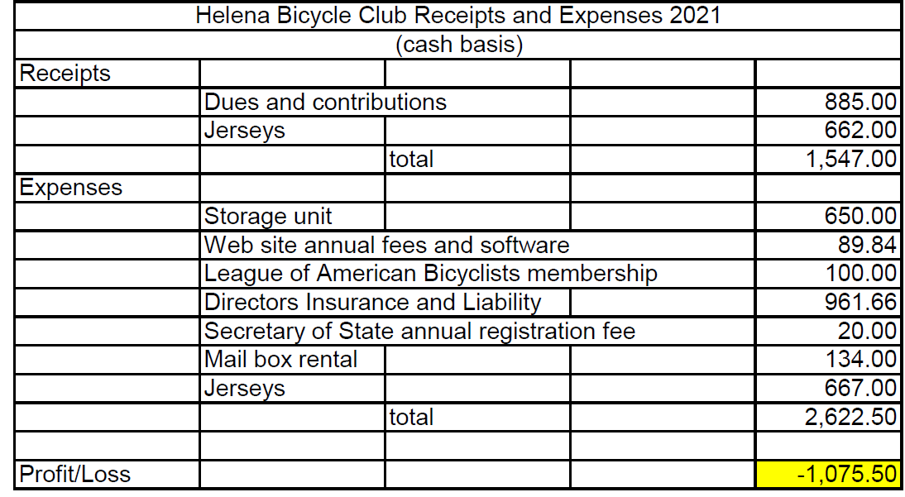

Total income for 2021 so far is $1,547, and total expenses, $2,622.50 with a loss of $1,075.50. The Club has 2 more months to go on the storage unit, then website fees will be coming up in the approximate amount of $250 by the end of the year.
61 individuals paid membership dues, including 17 families. The Club has a balance of approximately $10,000. The Club is still viable club with fun rides.
Rick Bush moved to return to the higher membership fees the Club charged in the past: $20 for individuals, $30 to families. Gretchen Krum seconded. No further discussion. The motion passed. We will need to change forms on the website to reflect the revised membership fees.
Dave suggested sending out a notice in November or December that dues are due, and we are going back to the original fee.
- Recap of 2021 Rides
Dan provided a recap of the year’s rides.
- Tuesday & Thursday/Saturday: 6 or more people rode at the beginning of the season, then the number tapered off later in the season. There were several Saturday morning rides as well. The first couple had good attendance, then dwindled.
- York Burger Boogie: There was a good turn out—about 12+ people.
- Bouler Ice Cream: Another good turnout—about 8-10 people. Half the people who rode were from outside Helena with one from Los Angeles.
- Trail of the Coeur d’Alenes: More than 13 people, well-attended. One ride Saturday and another Sunday with two good meals. Dan said that a group expedition ride like the Trail of the Coeur d’Alenes makes sense rather than hosting big rides like a century or the DDR. There is less burden organizing a group ride than the bigger rides.

- Next Meeting
For the next meeting, we will plan rides for next year. We will keep the “old faithfuls” and maybe do something similar to Coeur d’Alenes next year. Think about doing the West Yellowstone ride.
Dave Campana suggested the Spokane Centennial Trail. We can ride from Spokane to Coeur d’Alene for 60 miles or go to downtown Spokane.
There was some discussion about the Bitterroot Trail from Missoula to Hamilton. Rick has done some of this trail, but it is kind of disconnected.
Someone asked if there is a trail from Butte to Anaconda, following the creek. Dave said Butte to Ramsey has a nice trail, but it is not very long.
Polson to Ronan has a trail, but Polson has high-priced hotels. There is a nice trail in Kalispell 10-15 miles long. There is also one in Whitefish.

The next meeting will be held January 25th to establish goals for summer rides. Hopefully we will be able to meet in person. Dan will try to get a meeting room.
- Mary Ann Well bank’s Tour of the San Juan Islands
Mary Ann gave a PowerPoint presentation of her September ride through the San Juan Islands in Washington State.
The meeting was adjourned after the presentation.

